**OUTPUT**

**ACCOUNT:**

**Google Chrome Browser:**

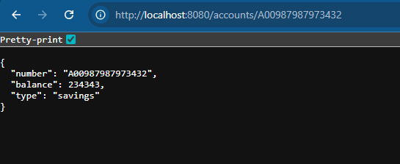

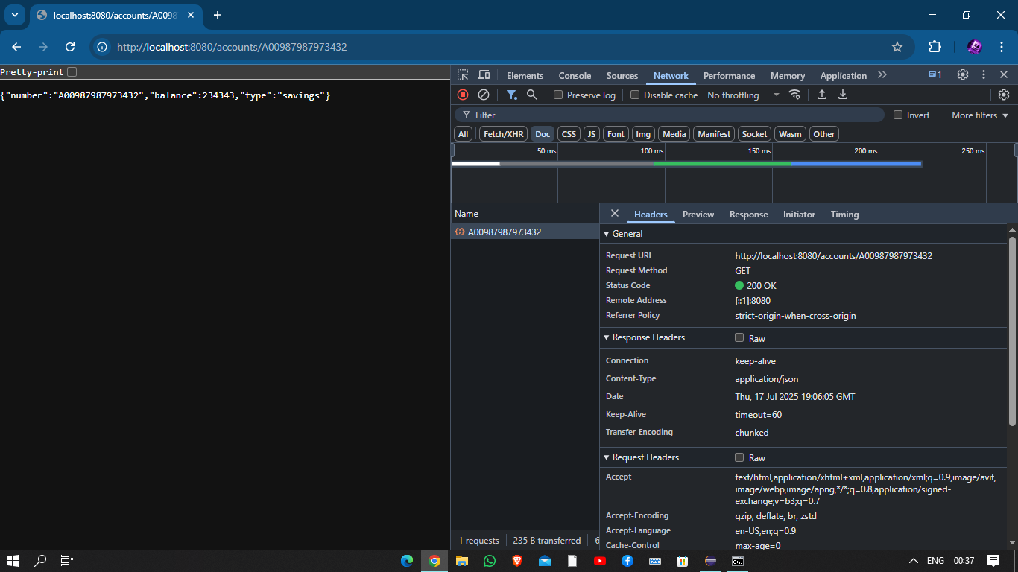

**Postman:  
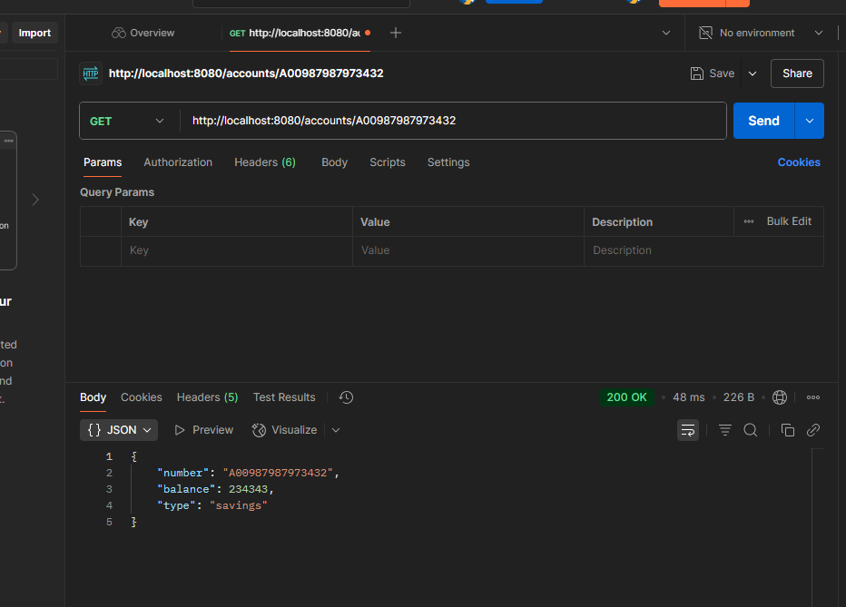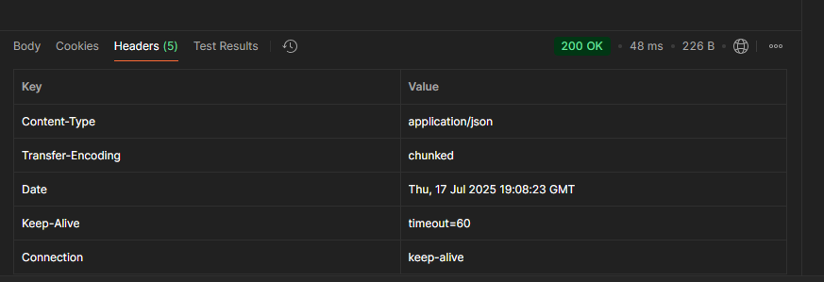**

**Eclipse Console:**

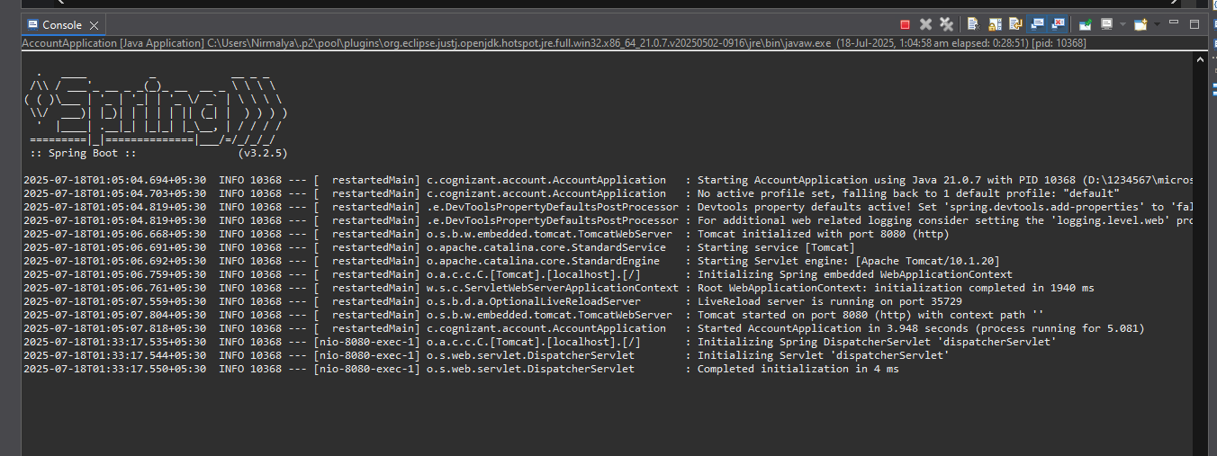

**-----------------------------------------------------------------**

**LOAN:**

**Google Chrome Browser:**

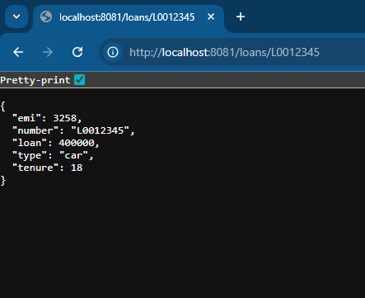

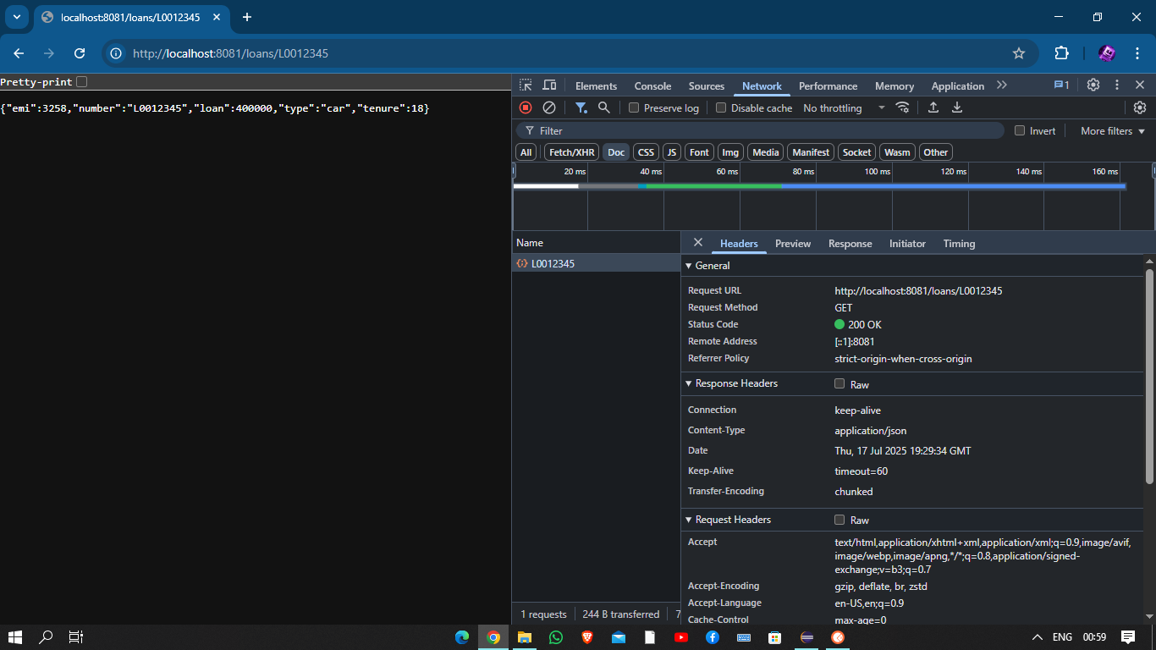

**Postman:**

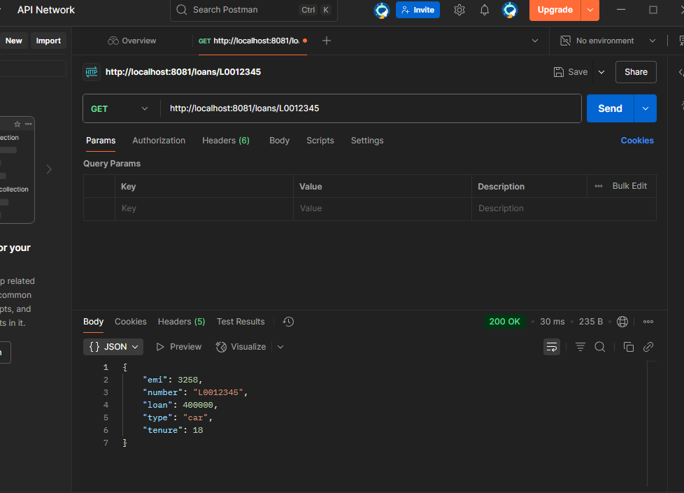

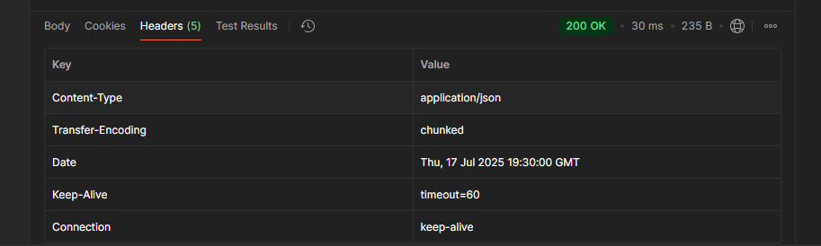

**Eclipse Console:**

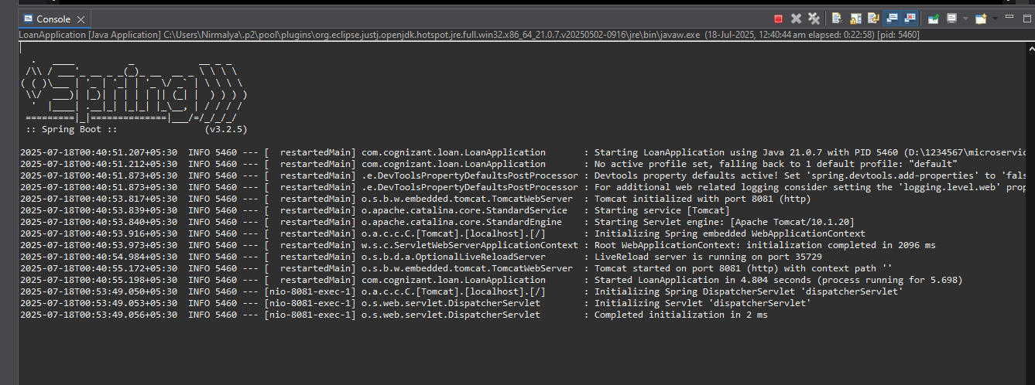

**----------------------------------------------------------------**

**FOLDER PATH :**

